

WhatsApp Pay
Simplilearn Project for CBAP Course
By- Kaveri.

Table of Content-
Task 1- Introduction
Business Analysis Core Concept Model (BACCM)
Requirement Classification Schema (RCS)
Task 2- Identification of Stakeholders
- List of internal and external stakeholders.
- Stakeholder Matrix
- RACI Matrix
- Stakeholder Onion Diagram
Task 3- Risk Identification in new feature.
Task 4- SWOT Analysis for WhatsApp pay feature.
Task 5- Identification of Transition state of WhatsApp Pay.
Task 6- Future Process Map (Flowchart).
Task 7- Scope of WhatsApp Pay System.
- UML (Use case Diagram).
- Context Diagram.
Task8- Features
Task 9- In scope and Out of Scope Requirements.
Task 10- Functional and Non- Functional Requirements.
Task 11- Wireframe.

Task 1
Introduction
WhatsApp is a Facebook-owned service of messaging and Voice over IP (VoIP). It allows users to send text, voice, and videos, share images, documents, and other media. WhatsApp is available on mobile devices but also on desktop computers. WhatsApp now has worldwide more than 2 billion users. In many countries across multiple continents, including Latin America, the Indian subcontinent, and many other areas of Europe and Africa.

Business Analysis Core Concept Model
(BACCM)

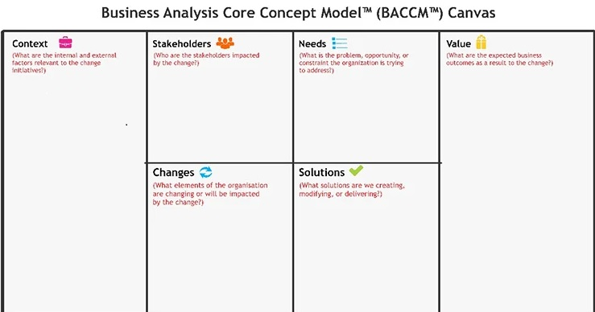

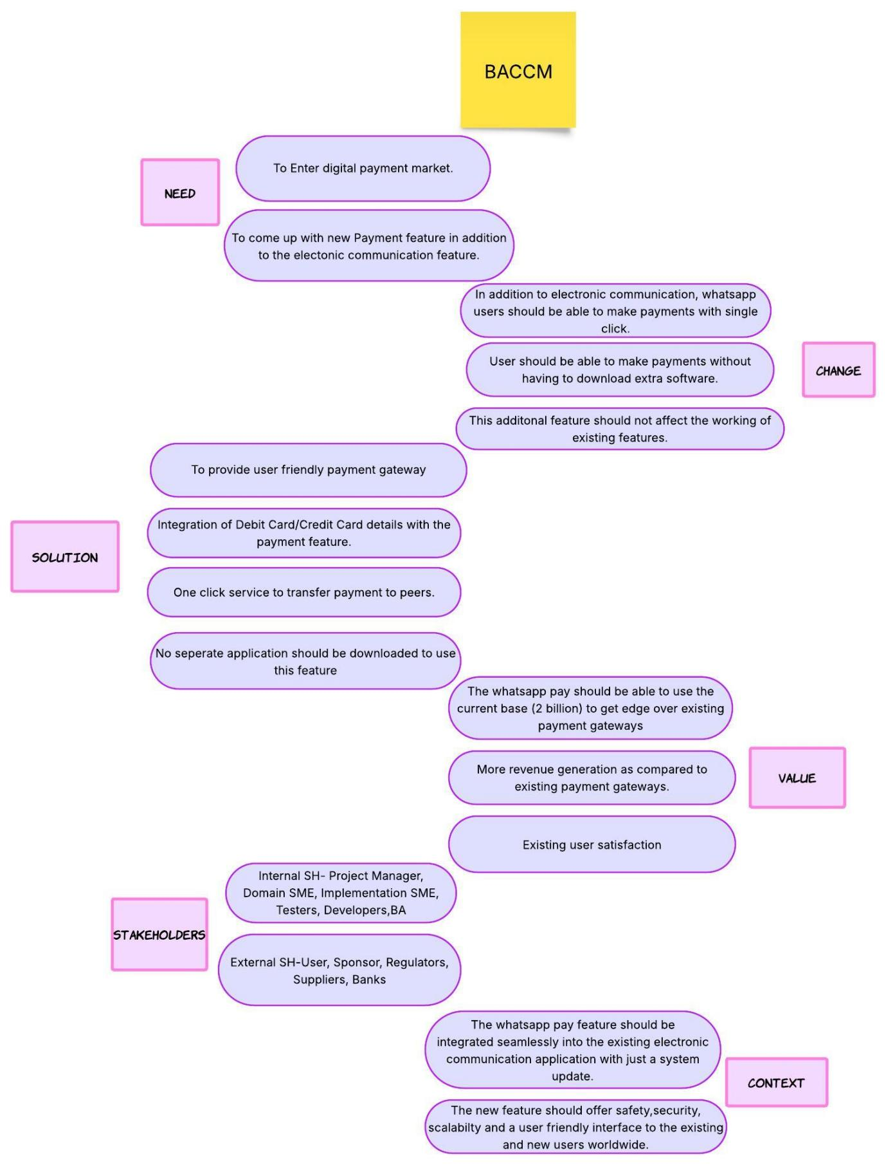

Requirement Classification Schema (RCS)
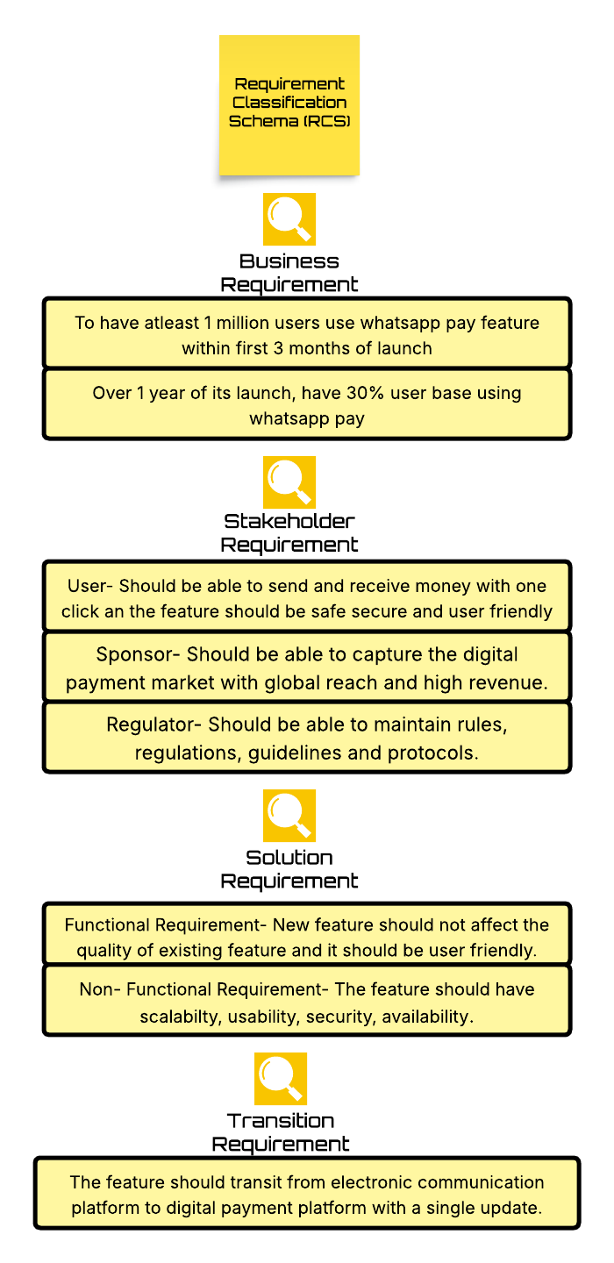
Task 2
Identification of Stakeholders
- List of internal and external Stakeholders
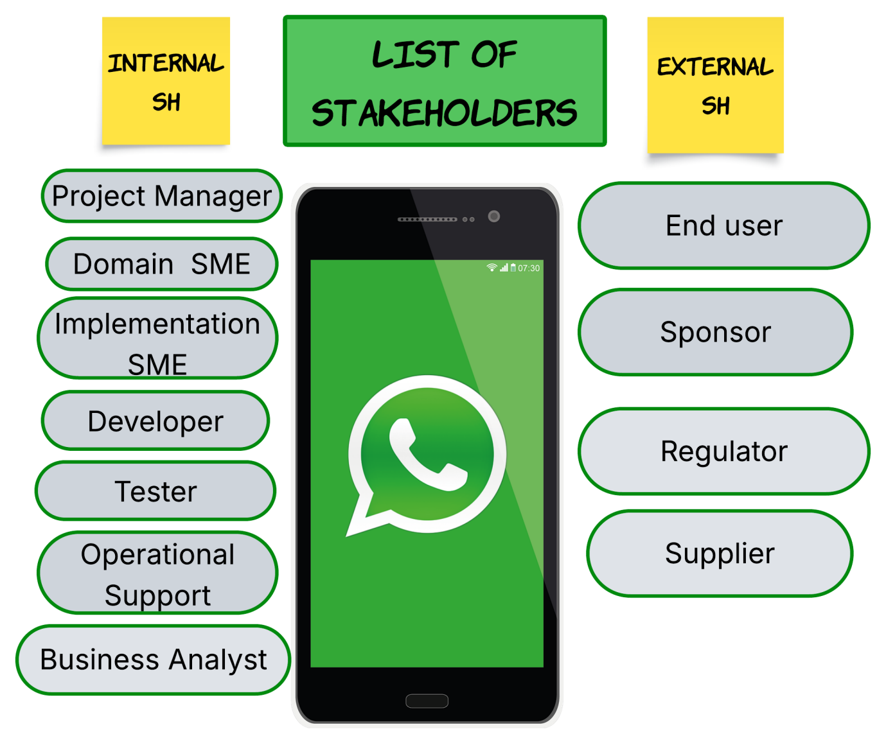

- Stakeholder Matrix
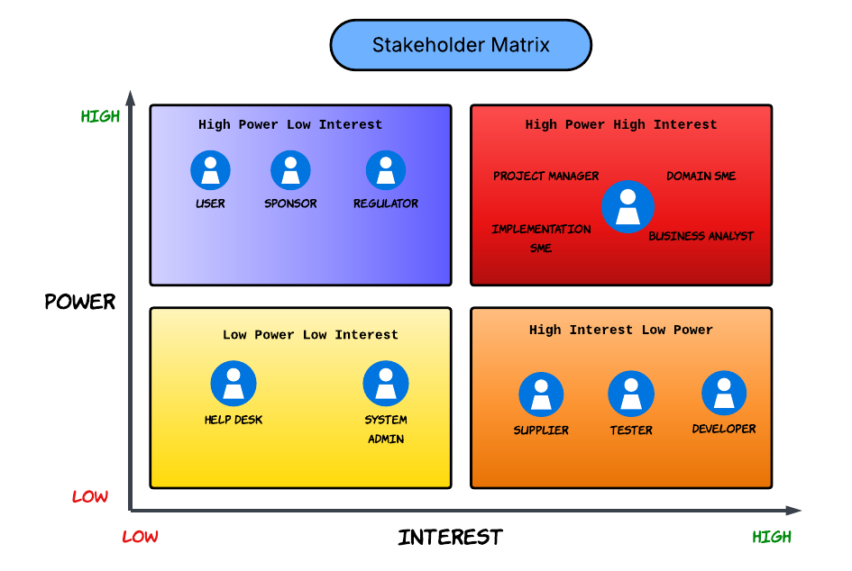
- RACI Matrix
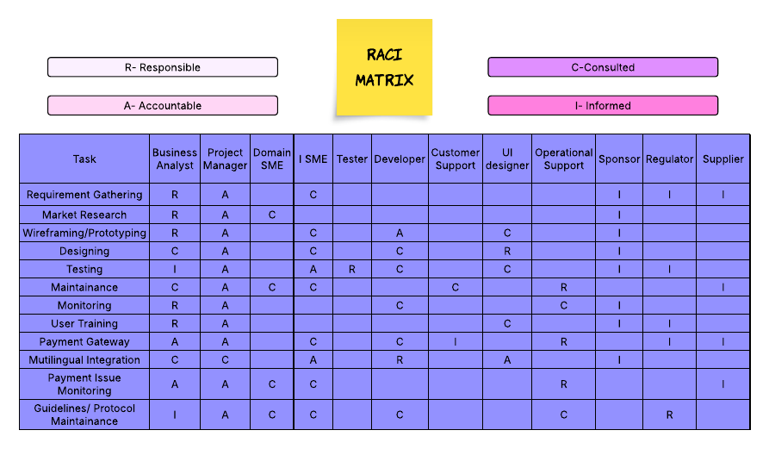

- Stakeholder Onion Diagram
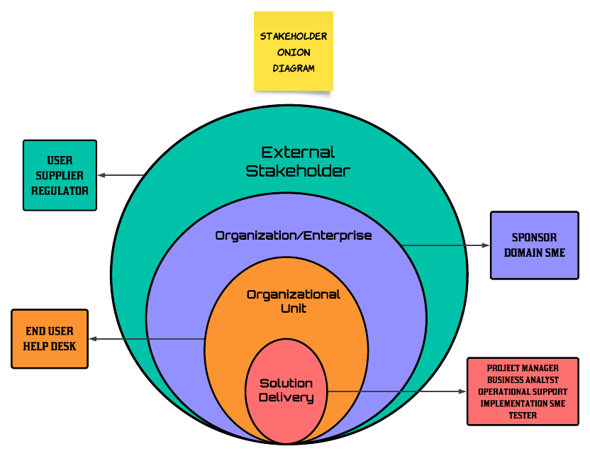

Task 3

Risk Identification
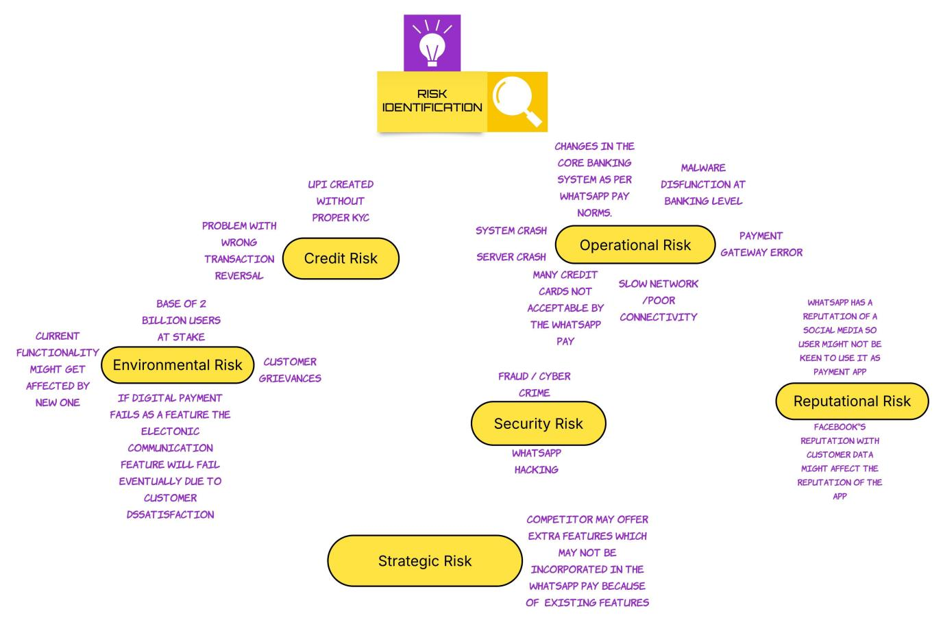
- Risk Identification with Fish Bone Diagram
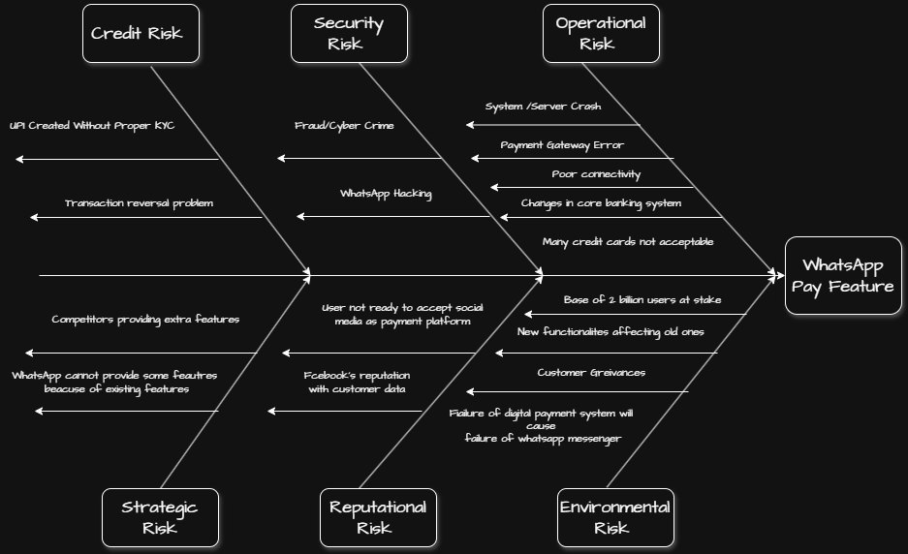
Task 4
SWOT Analysis
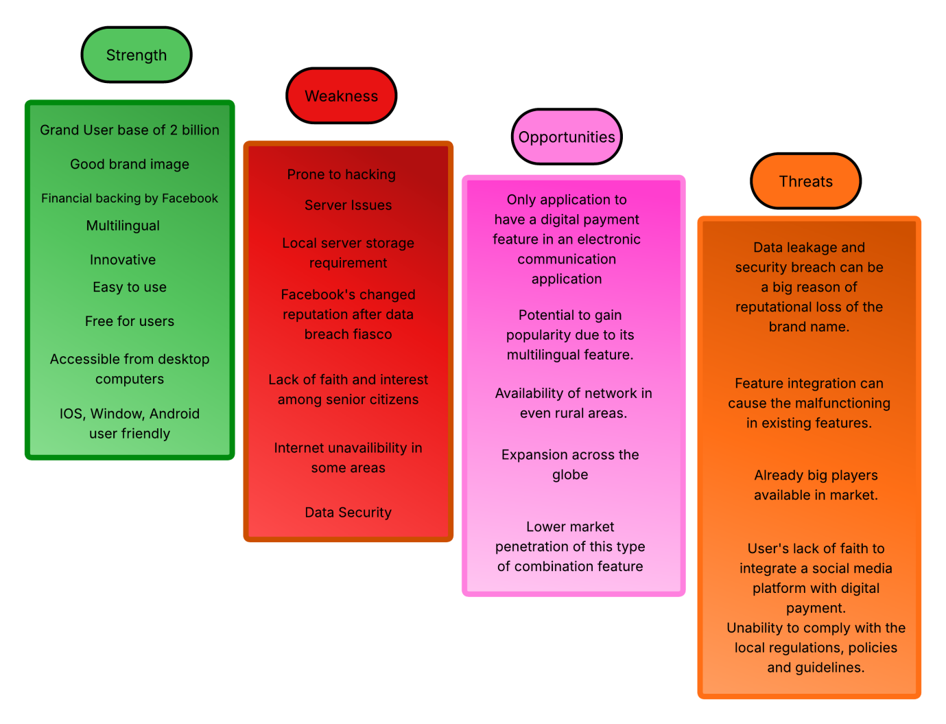
Strategy Analysis
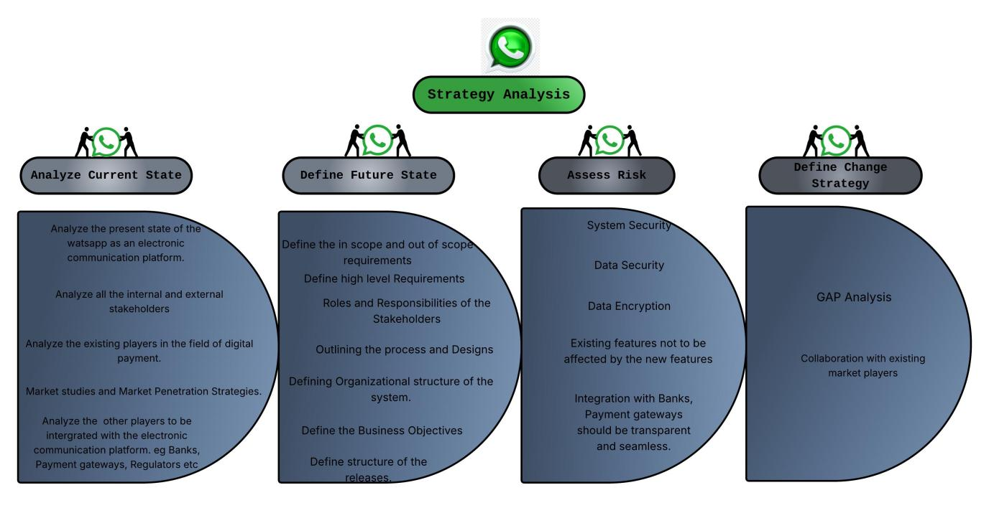
Task 5
Identification of Transition state
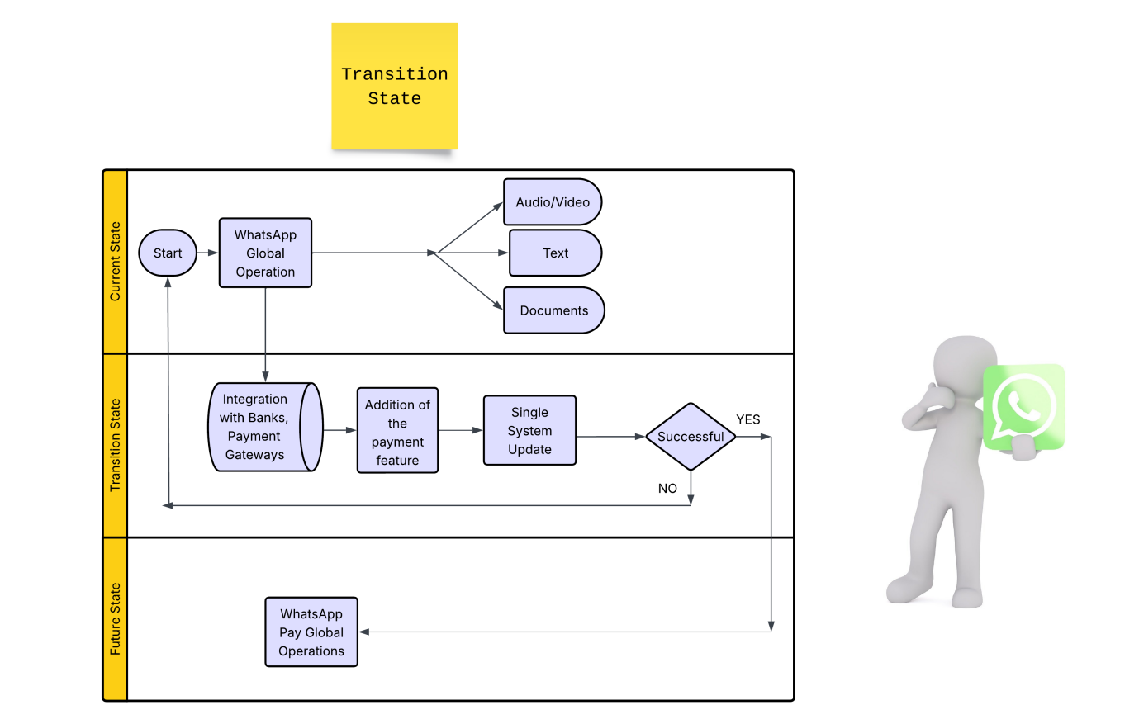

Task 6
Future Process Map
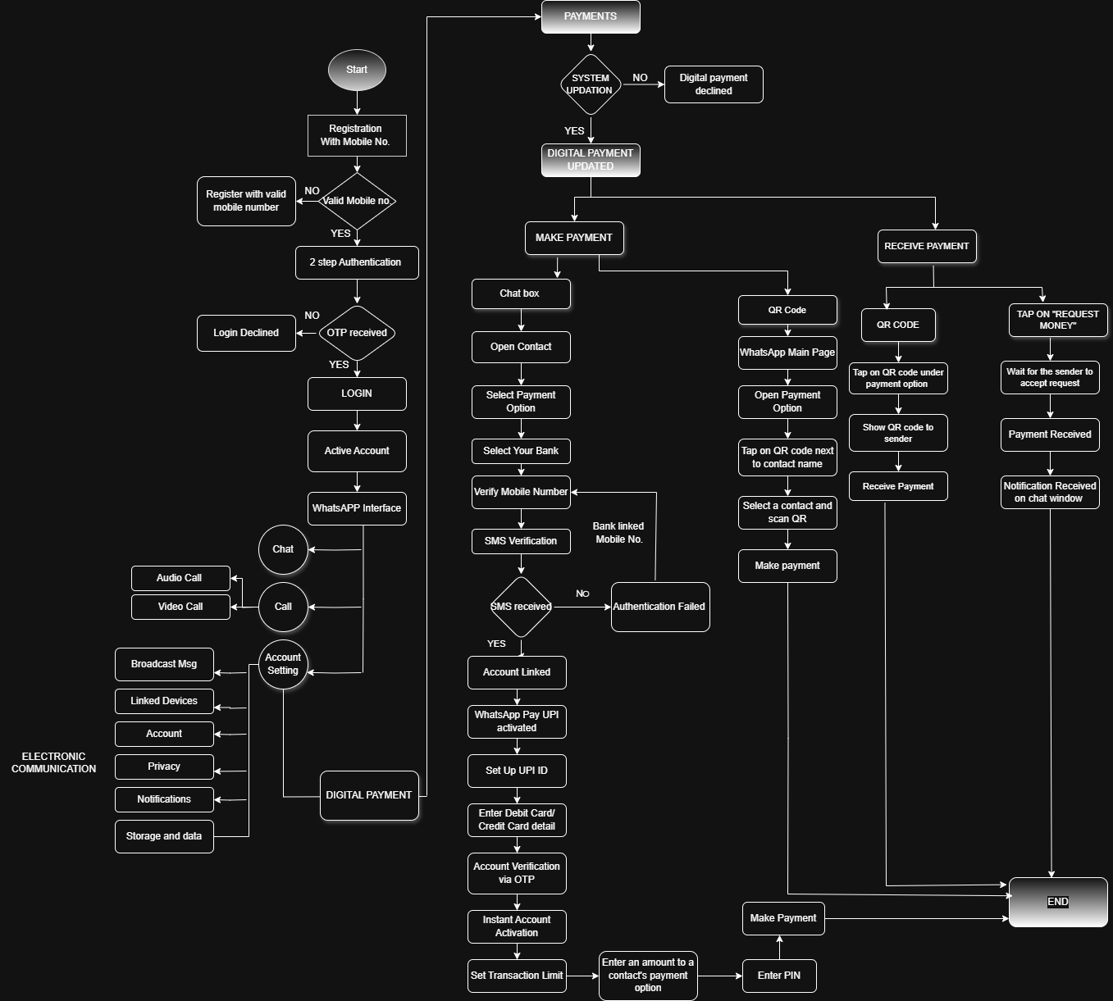

Task 7
Scope of the System
- UML (Use Case Diagram)
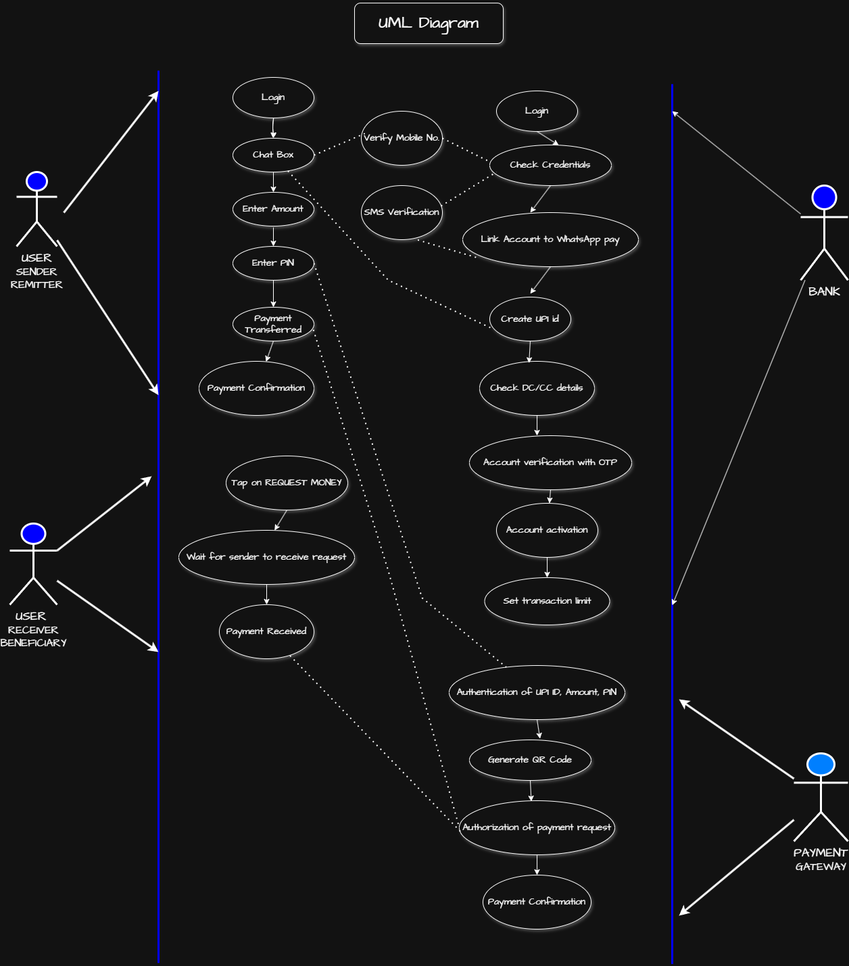

- Context Diagram
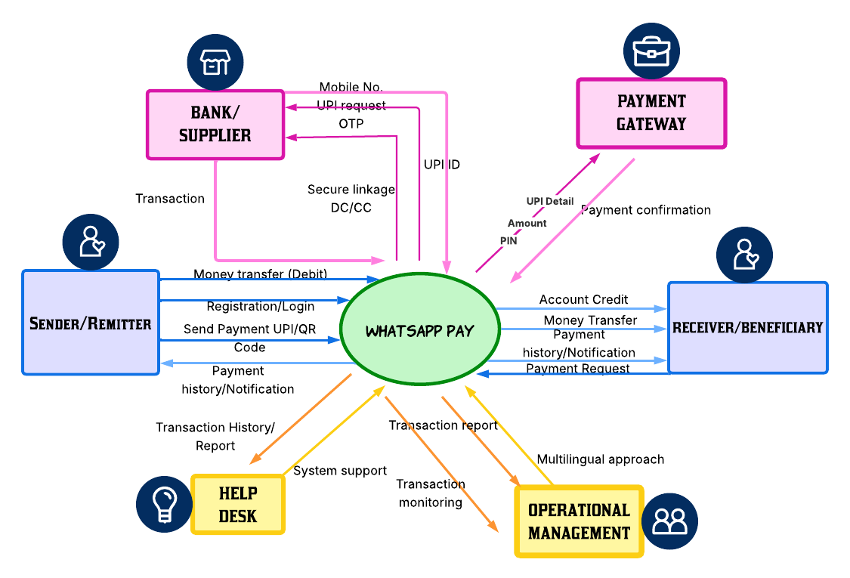

Task 8

Main Features
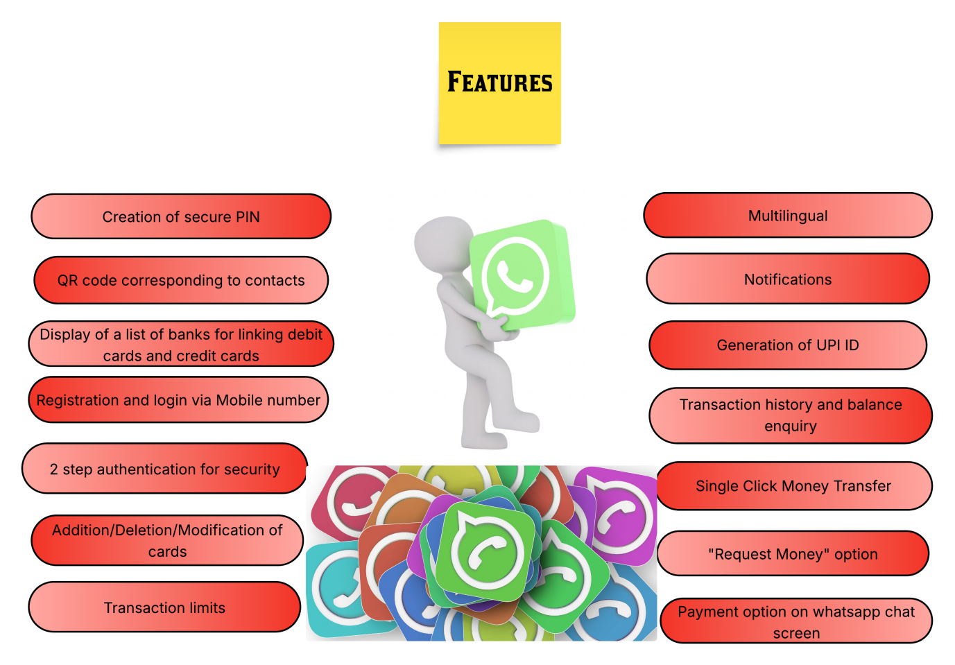

Task 9
In Scope and Out of Scope Requirements
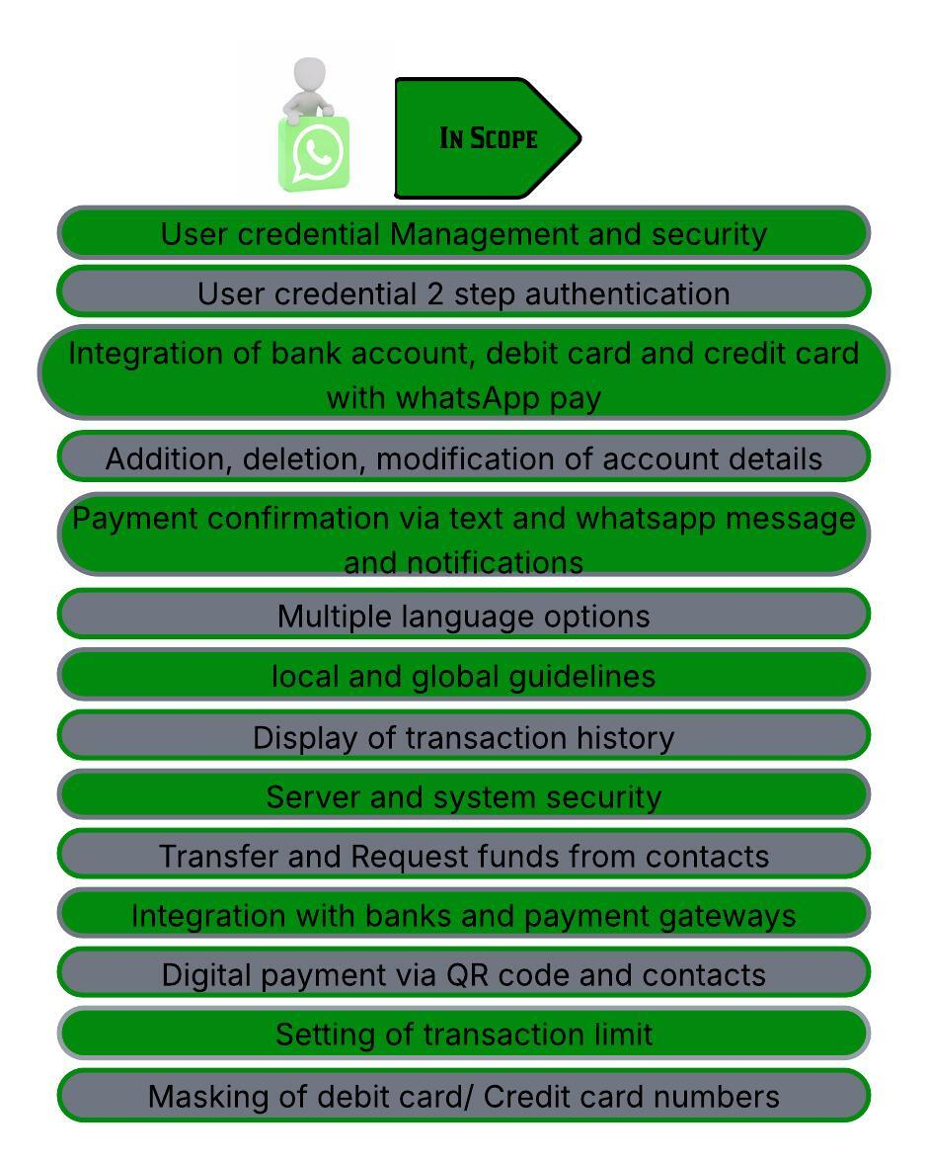
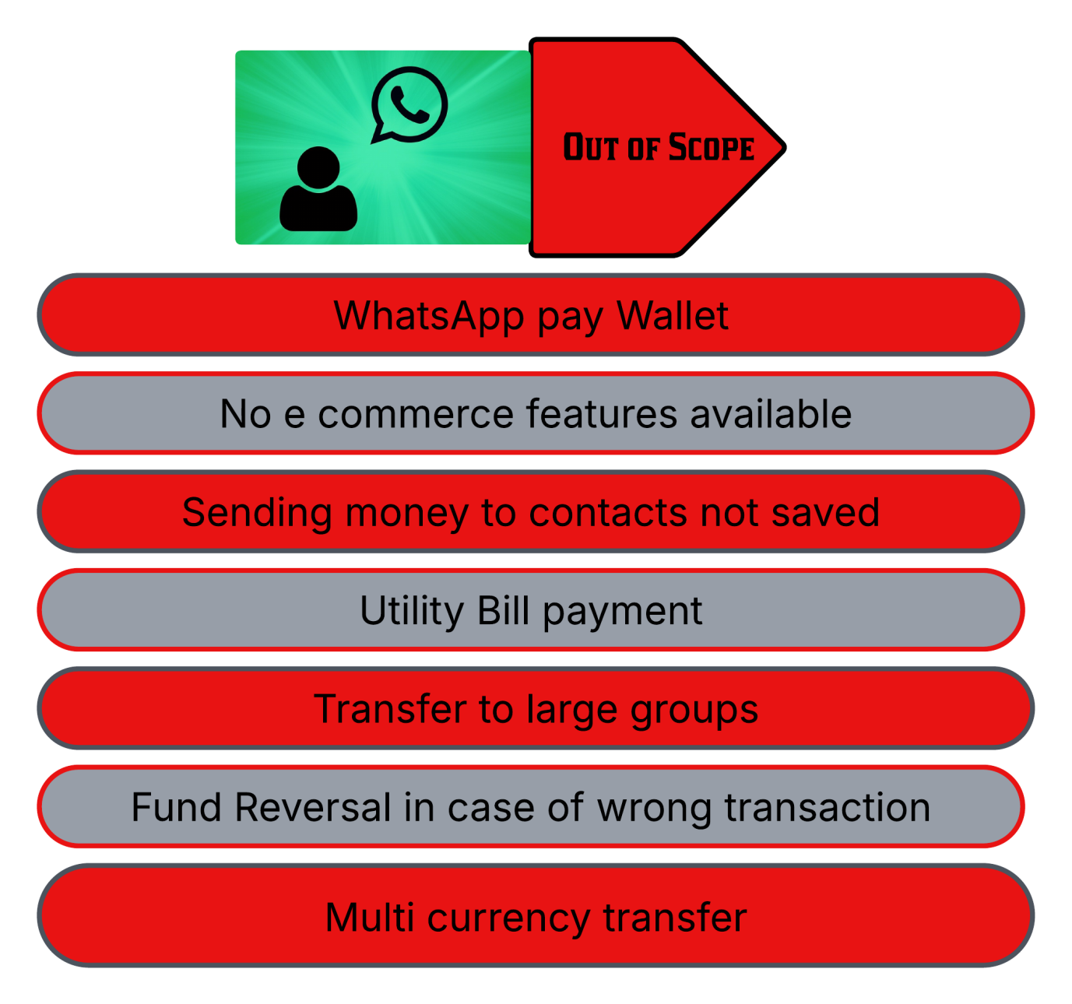

Task 10
Functional and Non Functional Requirements
- Functional Requirements
- User should be able to register and login to WhatsApp Pay with proper credentials.
- User should be able to add contacts to the whatsApp contacts list for payment.
- User should be able to access the payment account details in the menu.
- User should be able to integrate whatsapp messenger with whatsapp pay with single update.
- User should be able to select bank with an active account.
- User should be able to activate payment mode by verification of mobile number.
- User should be able to do the SMS verification in order to link the desired bank account with the whatsapp pay.
- User should be able to enter debit card/ credit card details for account linking.
- User should be able to received OTP for DC/CC linkage verification and PIN generation.
- User should be able to set the transaction limit.
- User should be able to enter PIN to authorize the payment.
- User should be able to view the QR code besides contact list to tap for payment feature.
- User should be able to tap on REQUEST MONEY to send a request for receiving payment.
- User should be able to receive notifications of ongoing transactions.
- User should be able to link multiple bank accounts to the digital payment system.
- User should be able to track the balance and the transaction history in the menu.
- User should be able to mask the debit card/ credit card numbers for cyber security purposes.
- Bank should be able to verify the credentials of the user.
- Bank should be able to verify the status of the account. (active/inactive).
- Bank should be able to verify the mobile number with the help of SMS verification process.
- Bank should be able to generate UPI id correspondent to the account linked.
- Bank should be able to verify the debit card /credit card details and credentials for secure linkage of the account to the digital payment mode.
- Bank should be able to provide OTP to the customer for PIN set up.
- Bank should be able to provide authorization to the user for setting up the transaction limit.
- Payment gateway should be able to authenticate the UPI ID, Amount and PIN required for making payment.
- Payment gateway should be able to generate the QR code specific for every user for payment transfer process.
- Payment gateway should be able to authorize every transaction initiated by the user post bank verification.
- Operational Management Team should be able to monitor the transactions as per the policy guidelines and compliance parameters set by the regulators.
- OM Team should be able to create and monitor a multilingual platform for global reach.
- OM Team should be able to generate the transaction reports.
- OM Team should be able to share the transaction and compliance reports with the correspondent bank and the regulators.
- OM Team should be able to maintain a security system for safe digital payment environment for the users by providing a privacy lock feature and 2 step authentication process.

- Non Functional Requirements
- Security- WhatsApp pay should be able to handle user credentials with security. Transactions must be encrypted end to end.
- Scalability- WhatsApp Pay should be able to handle 2 billion user base with a new added feature.It should be capable to accommodate more users.
- Performance- WhatsApp pay should be able to provide enhanced service quality to the user for better user experience.
- Usability- Whatsapp pay should be an easy feature to understand and use to simplify usage for users specially Senior citizens. It should be self explanatory.
- Availability- Whatsapp pay should be available for users 24*7.
- Compatibility- Additional feature should not affect the current feature in any manner.
- Compliance- Whatsapp pay should be able to comply with regulators policies and guidelines.

Task 11
Wireframe

